Lab Report No 10

Implementation of Image compression using Quantization
Digital Image Processing



Submitted By:
[Huzaifa Shahbaz]
[21-CE-009]
[Aqsa Shah]
[21-CE-039]

Submitted to:
Engr. Hareem Khan
Dated:
13thDec,2024

Department of Computer Engineering,
HITEC University, Taxila
Task No 1:

Solution:
Brief description (3-5 lines)
Standard Quantization takes an arbitrary number of levels and, through nearest-level mapping of pixel intensities, reduces these levels to whatever bit depth has been chosen (for example, 4, 6, 8, 16 bits). This gives a uniform quantization step size. The Improved Gray Scale (IGS) added an error feedback system in which the current pixel is calculated along with the quantization error from the last pixel to facilitate smoother feedback without contouring. Both were used to scale the original 8-bit pixel values to lower-bit versions by fitting the pixel intensities to the reduced levels. While standard quantization produces a sudden change, IGS minimizes these artifacts by retaining relative variations of the intensities. Trade off, then, is image quality against file size-reduced version-Igs only better visual quality under present bit depth.
The code
import numpy as np
import cv2
import matplotlib.pyplot as plt
def standard_quantization(image, bits):
levels = 2 ** bits
quantized_image = np.floor(image / (256 / levels)) * (256 / levels)
return quantized_image.astype(np.uint8)
def igs_quantization(image, bits):
levels = 2 ** bits
quantized_image = np.zeros_like(image, dtype=np.uint8)
error = 0
for row in range(image.shape[0]):
for col in range(image.shape[1]):
pixel_value = image[row, col]
new_value = (pixel_value + error) // (256 // levels) * (256 // levels)
error = pixel_value + error - new_value
quantized_image[row, col] = new_value
return quantized_image
def plot_images(original, quantized_images, title_prefix):
plt.figure(figsize=(10, 8))
plt.subplot(2, 3, 1)
plt.imshow(original, cmap='gray')
plt.title("Original")
plt.axis('off')
for i, (bits, q_image) in enumerate(quantized_images):
plt.subplot(2, 3, i + 2)
plt.imshow(q_image, cmap='gray')
plt.title(f"{title_prefix} {bits}-bit")
plt.axis('off')
plt.tight_layout()
plt.show()
# Load the grayscale image
image_path = ('APPLEANDTREE.jpg')
image = cv2.imread(image_path, cv2.IMREAD_GRAYSCALE)
if image is None:
raise ValueError("Image not found or not readable.")
# Perform quantization
bit_depths = [4, 6, 8, 16]
standard_quantized_images = [(bits, standard_quantization(image, bits)) for bits in bit_depths]
igs_quantized_images = [(bits, igs_quantization(image, bits)) for bits in bit_depths]
# Plot results
plot_images(image, standard_quantized_images, "Standard Quantization")
plot_images(image, igs_quantized_images, "IGS Quantization")
The results (Screenshot)
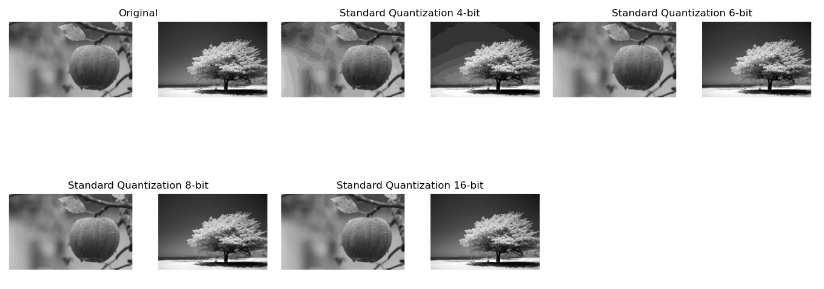
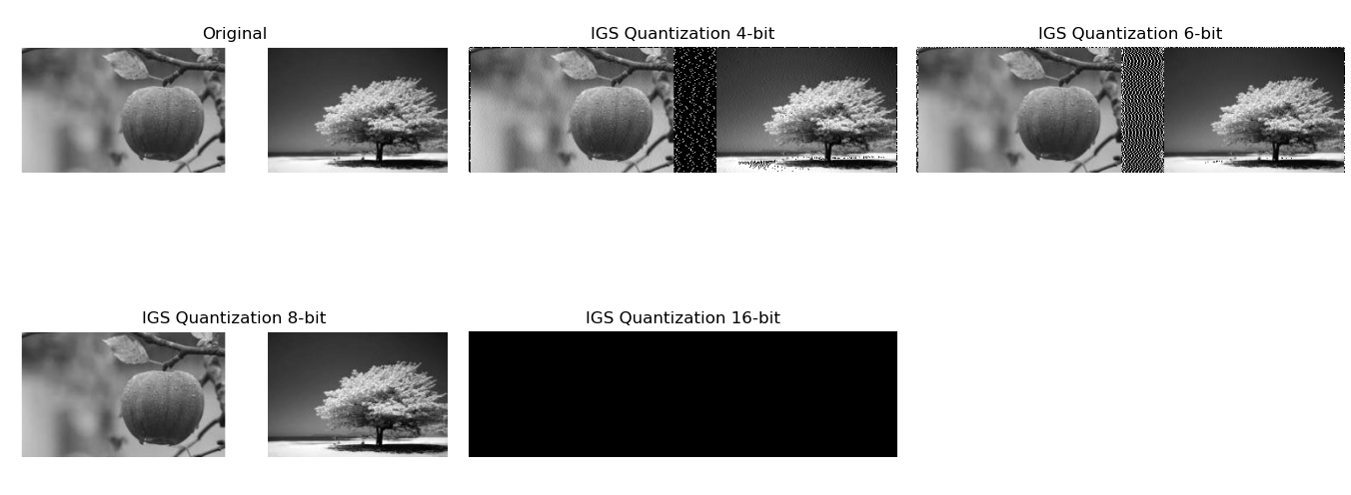
Lab Task No 2:

Solution:
Brief description (3-5 lines)
COLOR SCALING:
Quantization in Standard:
Linear mapping of color values spread evenly into uniform color space.
Quantization in IGS:
Non-linear scaling better preserve perceptual color relationship than mere uniform sampling.
Standard method:
The step sizes between quantization levels are equal to that which may cause color bandings.
IGS method:
Adapted step sizes:
More levels are concentrated perceptually important areas.
Perceptual priority in IGS- finer representation for high sensitivity areas.
The code
import cv2
import numpy as np
import matplotlib.pyplot as plt
# Load the image
image = cv2.imread('COLORSCALING.jpg') # Replace 'image.jpg' with your image path
image = cv2.cvtColor(image, cv2.COLOR_BGR2RGB) # Convert from BGR to RGB
# Function to perform image quantization
def quantize_image(image, levels):
step = 256 // levels
quantized = (image // step) * step + step // 2
return np.clip(quantized, 0, 255).astype(np.uint8)
# Quantize the image with a given number of levels
quantized_image_4 = quantize_image(image, levels=4)
quantized_image_8 = quantize_image(image, levels=8)
quantized_image_6 = quantize_image(image, levels=6)
quantized_image_16 = quantize_image(image, levels=16)
# Function to perform intensity slicing
def intensity_slice(channel, min_val, max_val):
sliced = np.zeros_like(channel)
sliced[(channel >= min_val) & (channel <= max_val)] = channel[(channel >= min_val) & (channel <= max_val)]
return sliced
# Slice intensity ranges for each channel
red_channel, green_channel, blue_channel = image[:, :, 0], image[:, :, 1], image[:, :, 2]
red_sliced = intensity_slice(red_channel, 100, 200)
green_sliced = intensity_slice(green_channel, 50, 150)
blue_sliced = intensity_slice(blue_channel, 0, 100)
# Quantize the sliced channels
red_quantized_4 = quantize_image(red_sliced, levels=4)
green_quantized_4 = quantize_image(green_sliced, levels=4)
blue_quantized_4 = quantize_image(blue_sliced, levels=4)
red_quantized_8 = quantize_image(red_sliced, levels=8)
green_quantized_8 = quantize_image(green_sliced, levels=8)
blue_quantized_8 = quantize_image(blue_sliced, levels=8)
red_quantized_6 = quantize_image(red_sliced, levels=6)
green_quantized_6 = quantize_image(green_sliced, levels=6)
blue_quantized_6 = quantize_image(blue_sliced, levels=6)
red_quantized_16 = quantize_image(red_sliced, levels=16)
green_quantized_16 = quantize_image(green_sliced, levels=16)
blue_quantized_16 = quantize_image(blue_sliced, levels=16)
# Display the results
fig, axs = plt.subplots(5, 4, figsize=(20, 20))
# Original image and quantized images
axs[0, 0].imshow(image)
axs[0, 0].set_title("Original Image")
axs[0, 0].axis('off')
axs[0, 1].imshow(quantized_image_4)
axs[0, 1].set_title("Quantized (4 levels)")
axs[0, 1].axis('off')
axs[0, 2].imshow(quantized_image_8)
axs[0, 2].set_title("Quantized (8 levels)")
axs[0, 2].axis('off')
axs[0, 3].imshow(quantized_image_6)
axs[0, 3].set_title("Quantized (6 levels)")
axs[0, 3].axis('off')
axs[1, 0].imshow(quantized_image_16)
axs[1, 0].set_title("Quantized (16 levels)")
axs[1, 0].axis('off')
# Red channel slicing and quantization
axs[1, 1].imshow(red_sliced, cmap='Reds')
axs[1, 1].set_title("Red Channel Sliced")
axs[1, 1].axis('off')
axs[1, 2].imshow(red_quantized_4, cmap='Reds')
axs[1, 2].set_title("Red Channel Quantized (4 levels)")
axs[1, 2].axis('off')
axs[1, 3].imshow(red_quantized_8, cmap='Reds')
axs[1, 3].set_title("Red Channel Quantized (8 levels)")
axs[1, 3].axis('off')
axs[2, 0].imshow(red_quantized_6, cmap='Reds')
axs[2, 0].set_title("Red Channel Quantized (6 levels)")
axs[2, 0].axis('off')
axs[2, 1].imshow(red_quantized_16, cmap='Reds')
axs[2, 1].set_title("Red Channel Quantized (16 levels)")
axs[2, 1].axis('off')
# Green channel slicing and quantization
axs[2, 2].imshow(green_sliced, cmap='Greens')
axs[2, 2].set_title("Green Channel Sliced")
axs[2, 2].axis('off')
axs[2, 3].imshow(green_quantized_4, cmap='Greens')
axs[2, 3].set_title("Green Channel Quantized (4 levels)")
axs[2, 3].axis('off')
axs[3, 0].imshow(green_quantized_8, cmap='Greens')
axs[3, 0].set_title("Green Channel Quantized (8 levels)")
axs[3, 0].axis('off')
axs[3, 1].imshow(green_quantized_6, cmap='Greens')
axs[3, 1].set_title("Green Channel Quantized (6 levels)")
axs[3, 1].axis('off')
axs[3, 2].imshow(green_quantized_16, cmap='Greens')
axs[3, 2].set_title("Green Channel Quantized (16 levels)")
axs[3, 2].axis('off')
# Blue channel slicing and quantization
axs[3, 3].imshow(blue_sliced, cmap='Blues')
axs[3, 3].set_title("Blue Channel Sliced")
axs[3, 3].axis('off')
axs[4, 0].imshow(blue_quantized_4, cmap='Blues')
axs[4, 0].set_title("Blue Channel Quantized (4 levels)")
axs[4, 0].axis('off')
axs[4, 1].imshow(blue_quantized_8, cmap='Blues')
axs[4, 1].set_title("Blue Channel Quantized (8 levels)")
axs[4, 1].axis('off')
axs[4, 2].imshow(blue_quantized_6, cmap='Blues')
axs[4, 2].set_title("Blue Channel Quantized (6 levels)")
axs[4, 2].axis('off')
axs[4, 3].imshow(blue_quantized_16, cmap='Blues')
axs[4, 3].set_title("Blue Channel Quantized (16 levels)")
axs[4, 3].axis('off')
plt.tight_layout()
plt.show()
import cv2
import numpy as np
import matplotlib.pyplot as plt
# Load the image
image = cv2.imread('COLORSCALING.jpg') # Replace 'image.jpg' with your image path
image = cv2.cvtColor(image, cv2.COLOR_BGR2RGB) # Convert from BGR to RGB
# Function to perform image quantization
def quantize_image(image, levels):
step = 256 // levels
quantized = (image // step) * step + step // 2
return np.clip(quantized, 0, 255).astype(np.uint8)
# Quantize the image with a given number of levels
quantized_image_4 = quantize_image(image, levels=4)
quantized_image_8 = quantize_image(image, levels=8)
quantized_image_6 = quantize_image(image, levels=6)
quantized_image_16 = quantize_image(image, levels=16)
# Function to perform intensity slicing
def intensity_slice(channel, min_val, max_val):
sliced = np.zeros_like(channel)
sliced[(channel >= min_val) & (channel <= max_val)] = channel[(channel >= min_val) & (channel <= max_val)]
return sliced
# Slice intensity ranges for each channel
red_channel, green_channel, blue_channel = image[:, :, 0], image[:, :, 1], image[:, :, 2]
red_sliced = intensity_slice(red_channel, 100, 200)
green_sliced = intensity_slice(green_channel, 50, 150)
blue_sliced = intensity_slice(blue_channel, 0, 100)
# Quantize the sliced channels
red_quantized_4 = quantize_image(red_sliced, levels=4)
green_quantized_4 = quantize_image(green_sliced, levels=4)
blue_quantized_4 = quantize_image(blue_sliced, levels=4)
red_quantized_8 = quantize_image(red_sliced, levels=8)
green_quantized_8 = quantize_image(green_sliced, levels=8)
blue_quantized_8 = quantize_image(blue_sliced, levels=8)
red_quantized_6 = quantize_image(red_sliced, levels=6)
green_quantized_6 = quantize_image(green_sliced, levels=6)
blue_quantized_6 = quantize_image(blue_sliced, levels=6)
red_quantized_16 = quantize_image(red_sliced, levels=16)
green_quantized_16 = quantize_image(green_sliced, levels=16)
blue_quantized_16 = quantize_image(blue_sliced, levels=16)
# Display the results
fig, axs = plt.subplots(5, 4, figsize=(20, 20))
# Original image and quantized images
axs[0, 0].imshow(image)
axs[0, 0].set_title("Original Image")
axs[0, 0].axis('off')
axs[0, 1].imshow(quantized_image_4)
axs[0, 1].set_title("Quantized (4 levels)")
axs[0, 1].axis('off')
axs[0, 2].imshow(quantized_image_8)
axs[0, 2].set_title("Quantized (8 levels)")
axs[0, 2].axis('off')
axs[0, 3].imshow(quantized_image_6)
axs[0, 3].set_title("Quantized (6 levels)")
axs[0, 3].axis('off')
axs[1, 0].imshow(quantized_image_16)
axs[1, 0].set_title("Quantized (16 levels)")
axs[1, 0].axis('off')
# Red channel slicing and quantization
axs[1, 1].imshow(red_sliced, cmap='Reds')
axs[1, 1].set_title("Red Channel Sliced")
axs[1, 1].axis('off')
axs[1, 2].imshow(red_quantized_4, cmap='Reds')
axs[1, 2].set_title("Red Channel Quantized (4 levels)")
axs[1, 2].axis('off')
axs[1, 3].imshow(red_quantized_8, cmap='Reds')
axs[1, 3].set_title("Red Channel Quantized (8 levels)")
axs[1, 3].axis('off')
axs[2, 0].imshow(red_quantized_6, cmap='Reds')
axs[2, 0].set_title("Red Channel Quantized (6 levels)")
axs[2, 0].axis('off')
axs[2, 1].imshow(red_quantized_16, cmap='Reds')
axs[2, 1].set_title("Red Channel Quantized (16 levels)")
axs[2, 1].axis('off')
# Green channel slicing and quantization
axs[2, 2].imshow(green_sliced, cmap='Greens')
axs[2, 2].set_title("Green Channel Sliced")
axs[2, 2].axis('off')
axs[2, 3].imshow(green_quantized_4, cmap='Greens')
axs[2, 3].set_title("Green Channel Quantized (4 levels)")
axs[2, 3].axis('off')
axs[3, 0].imshow(green_quantized_8, cmap='Greens')
axs[3, 0].set_title("Green Channel Quantized (8 levels)")
axs[3, 0].axis('off')
axs[3, 1].imshow(green_quantized_6, cmap='Greens')
axs[3, 1].set_title("Green Channel Quantized (6 levels)")
axs[3, 1].axis('off')
axs[3, 2].imshow(green_quantized_16, cmap='Greens')
axs[3, 2].set_title("Green Channel Quantized (16 levels)")
axs[3, 2].axis('off')
# Blue channel slicing and quantization
axs[3, 3].imshow(blue_sliced, cmap='Blues')
axs[3, 3].set_title("Blue Channel Sliced")
axs[3, 3].axis('off')
axs[4, 0].imshow(blue_quantized_4, cmap='Blues')
axs[4, 0].set_title("Blue Channel Quantized (4 levels)")
axs[4, 0].axis('off')
axs[4, 1].imshow(blue_quantized_8, cmap='Blues')
axs[4, 1].set_title("Blue Channel Quantized (8 levels)")
axs[4, 1].axis('off')
axs[4, 2].imshow(blue_quantized_6, cmap='Blues')
axs[4, 2].set_title("Blue Channel Quantized (6 levels)")
axs[4, 2].axis('off')
axs[4, 3].imshow(blue_quantized_16, cmap='Blues')
axs[4, 3].set_title("Blue Channel Quantized (16 levels)")
axs[4, 3].axis('off')
plt.tight_layout()
plt.show()
The results (Screenshot)
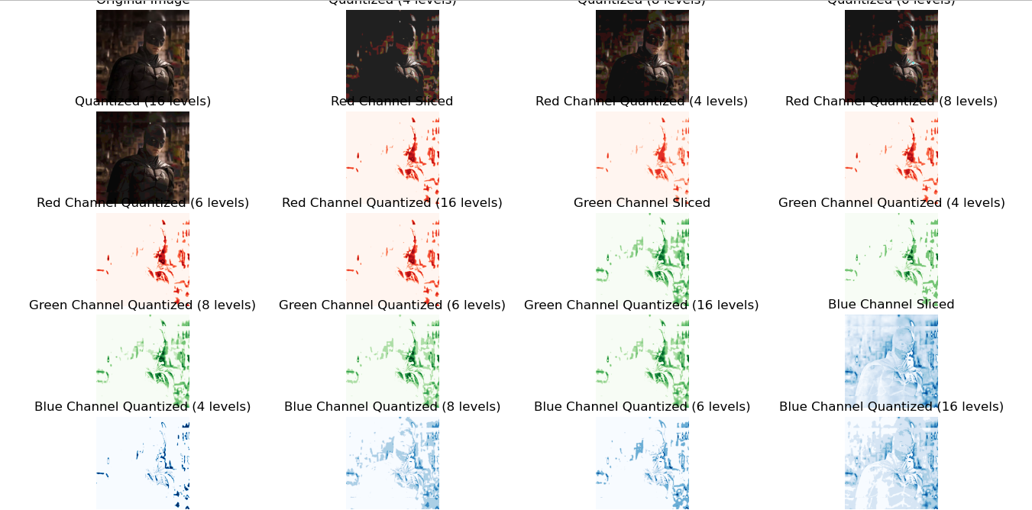

Conclusion
In conclusion,the quantization reduces the space that a digital image occupies; it is a practical and efficient method for image compression that preserves sufficiently acceptable visual quality. It takes images, divides the images into blocks and quantizes frequency coefficients and thus removes data that s needed. It further lowers the demand in terms of storage and bandwidth. One can achieve a varying trade-off for the compression ratio and image quality by simply modifying their quantization settings.

